- Lift the printhead latch.
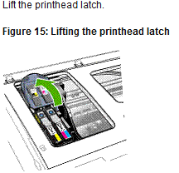

- Lift the handle of a printhead, and use it to pull the printhead out of its slot.
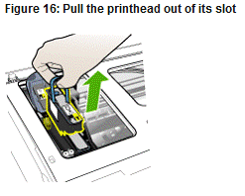
- Before installing a new printhead, shake the printhead up and down at least six times while the printhead is still in its packaging.

